# Assignment # 1

1. Any character is entered through the keyboard; write a program to determine whether the character entered is a capital letter, a small case letter, a digit, or a special symbol.

The following table shows the range of ASCII values for various characters.

**Characters ASCII values**

A – Z 65 – 90

a – z 97 – 122

0 – 9 48 – 57

Special symbols 0 – 47, 58 – 64, 91 – 96, 123 – 127

1. The following table contains earthquake magnitude ranges on the Richter scale and their descriptors:

|  |  |
| --- | --- |
| **Magnitude** | **Descriptor** |
| Less than 2.0 | Micro |
| 2.0 to less than 4.0 | Minor |
| 4.0 to less than 5.0 | Light |
| 5.0 to less than 6.0 | Moderate |
| 6.0 to less than 8.0 | Major |
| 8.0 to less than 10.0 | Great |
| 10.0 or more | Meteoric |

Write a program that reads a magnitude from the user and displays the appropriate descriptor as part of a meaningful message. For example, if the user enters 5.5 then your program should indicate that a magnitude 5.5 earthquake is considered to be a moderate earthquake.

1. Read a 3 digit number N from keyboard and find individual digits in unit’s place (U), ten’s place (T) and hundred’s place (H). Check U + T*10 + H*102 = N (given no)
2. Write a RANDOM NUMBER GUESSING GAME –
   * Hard code a random number as answer
   * Ask user for input of Number
   * If INPUT is greater, print **"Try again with a LOWER number"**
   * If INPUT is lower, print **"Try again with a HIGHER number"**
   * If INPUT is equal, print **">>>> YOU WIN....! <<<<"**
   * Give the user 3 tries to guess the number
3. Check whether a year is leap year or not?

In the calendar three criteria must be taken into account to identify leap years:

* + The year can be evenly divided by 4;
  + If the year can be evenly divided by 100, it is NOT a leap year, unless;
  + The year is also evenly divisible by 400. Then it is a leap year.

1. The total distance traveled by vehicle in ‘t’ seconds is given by distance=ut+1/2at2 where ‘u’ and ‘a’ are the initial velocity (m/sec) and acceleration (m/sec2). Write a C++ program to find the distance traveled at regular intervals of time given values of ‘u’ and ‘a’. The program should provide the flexibility to the user to select his own time intervals.
2. Print the value of y for given x=2 & z=4 and analyze the output.
   1. y = x++ + ++x;
   2. y= ++x + ++x;
   3. y= ++x + ++x + ++x;
   4. y = x>z;
   5. y= x>z? x:z;
   6. y = x&z;
   7. y= x>>2 + z<<1;
3. 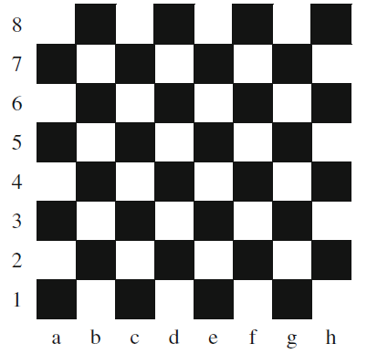Positions on a chess board are identified by a letter and a number. The letter identifies the column, while the number identifies the row, as shown below:

Write a program that reads a position from the user. Use an if statement to determine if the column begins with a black square or a white square. Then use modular arithmetic to report the color of the square in that row. For example, if the user enters a and 1 then your program should report that the square is black. If the user enters d and 5 then your program should report that the square is white. If a user enters a wrong position display an error message stating “Invalid Position”.

1. A particular cell phone plan includes 50 minutes of air time and 50 text messages for Rs. 15.00 a month. Each additional minute of air time costs Rs. 0.25, while additional text messages cost Rs. 0.15 each. All cell phone bills include an additional charge of Rs. 0.44 to support 911 call centers, and the entire bill (including the 911 charge) is subject to 5 percent sales tax.

Write a program that reads the number of minutes and text messages used in a month from the user. Display the base charge, additional minutes charge (if any), additional text message charge (if any), the 911 fee, tax and total bill amount. Only display the additional minute and text message charges if the user incurred costs in these categories. Ensure that all of the charges are displayed using floating point data type.